Take action

主要内容：

There are more and more endangered animals at present, so taking measures to protect animals is no longer an elective.

1. Raise people’s awareness of protecting animals, increasing the population of education for animal protection.
2. We have to prevent the environment from getting worse.
3. Stop killing the rare animals by perfecting relevant laws and taking some strict legal measures.

备注：

In conclusion, there are more and more animals in danger at present, so protecting them has been our task of top priority.

First, most of people don’t realize the importance of animals, but in some ways, they are more important than we think. For example, animals play a significant role in maintaining the balance of nature. In the matter of fact. not animals need us, but we need them. Without animals, we can hardly survive and develop. In a world, we are equal to animals. So we must raise people’s awareness of protecting animals by the way of education. 

Second, environment has been worse at a rapid rate. If we destroy the nature and take no actions in the face of environment’s getting worse, more and more species habitats will disappear, and then animals will die out. Thus we have to prevent the environment from getting worse.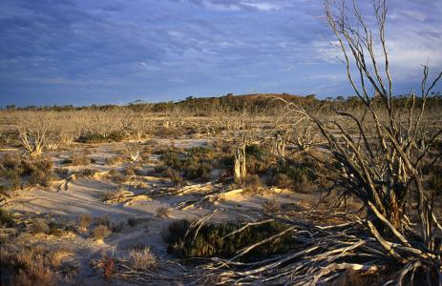

Last, a great number of people kill rare animals for money regardless of their survival, especially the youngers. Many poachers become crazy about killing wild animals just for their fur, leather and bones. More than 30,000 African elephants are killed for ivory each year. So calling on these people to stop killing animals is an essential way, and if necessary, we must take some legal actions. 